Jira : [new.starz.2025@gmail.com](mailto:new.starz.2025@gmail.com) : p=new.starz.2025 gm: santi*****25

https://new-starz.atlassian.net/jira/software/projects/JIR/boards/1/backlog

bandi.santoshi45@gmail.com

^^^^^^^^^^^^^^^^^^^^^^^^^^^^^^^^^^^^^^^^^^^^^^^^^^^^^^^^^^^^^^

Agile :Software development methodology. Is a iterative and incremental process

Scrum : is a framework thru whichwe build the software by agile principles.

Product backlog

Sprint backlog : Are the stories committed by the team

Sprint

Burn up-down chards

Retrospect

Scrun team: group of people

Product owner:

Scrum master

Dev team

QA team

Product Owner:

Responsible for requirement gathering

Defines the features of the product

Prioritize features account to the market value

He may accept or reject the work result

Scrum master: Main role is Facilitating and driving the agile process

Dev and QA : develop and test the software.

Scrum terminology

Epic : Bigger/larger requirement

Story : A feature/ module in the software. Basically small requirement

Product backlog: contains a list of user stories. Prepared by product owner

Sprint : a span of time usually between 2 to 4 weeks. Duration to complete the user stories.

Sprint planning meeting: It is a meeting conducted with the team to define what can be delivered in that sprint.

Sprint backlog : List of committed stores by the qa and dev for that sprint, Subset of product backlog

Scrum meeting: conducted by scrum master for 15 mins, to give the status

What they did yesterday

What they plan to do today

Are there any impediments in your way?

Sprint review: Metting help after sprint to check if all the isuues are resolved , it there is any open bug, Give a demo to the product owner.

Sprint retrospective meeting: conducted after completion of the sprint cycle to discuss what went well and what went wrong or any improvements needed for upcoming sprint. Everybody will participate in this meeting

Story points: rough estimation for the user story given by qa and dev in the form of fibbonacci series.

Burndown chart : shows how much work remaining in the sprint. Maintained by scrum master daily

Roles

Product owner

Scrum master

Team

Artifacts

Product backlog

Sprint backlog

Burndown chart

**Ceremonies**

Sprint planning

Daily scrum

Sprint review

Scrum board

Stories

To do

In progress

Testing

Done

Zero sprint :is the pre srrint period. Sprint 0 can be defined as the period when the Agile team assesses the amount of work needed.

What is spike story

A spike story in Agile is a user story that needs more information so the team can estimate how long the story will take to complete.

# What Is Spike In Agile

A spike story in Agile is a user story that needs more information so the team can estimate how long the story will take to complete.

A spike is a type of exploratory story that is undertaken in order to gain deeper knowledge and reduce risks, or to understand the requirement in greater detail. It could involve further research and exploration, as well as design and prototyping. It increases the reliability of a story, allowing the team to break it down further with greater accuracy and run an accurate estimate.

Roadmap in jira

* Roadmaps in Jira Software are team-level roadmaps useful for planning large pieces of work several months in advance at the Epic level within a single project. Simple planning and dependency management features help your teams visualize and manage work better together. Learn more about what your roadmap shows.

### [What are Jira workflows? | Jira Software Cloud | Atlassian ...](https://support.atlassian.com/jira-software-cloud/docs/what-are-jira-workflows/)

The path that your issues take is called a workflow. Each Jira workflow is composed of a set of statuses and transitions that your issue moves through during its lifecycle, and typically represents work processes within your organization. In addition, Jira uses workflow schemes to define the relationship between issue types and workflows.

**Issue types in jira**

Epic

story

Task

Subtask

Bug

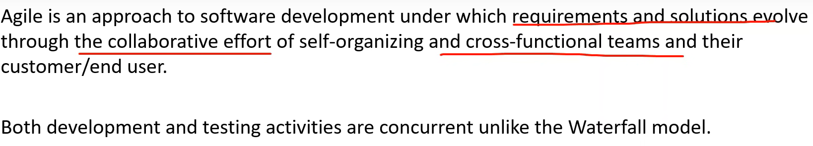

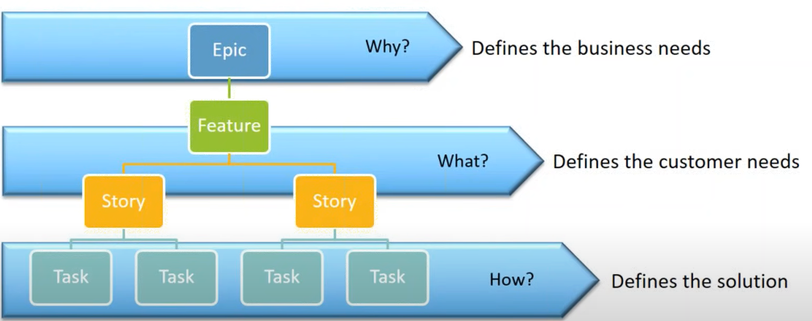

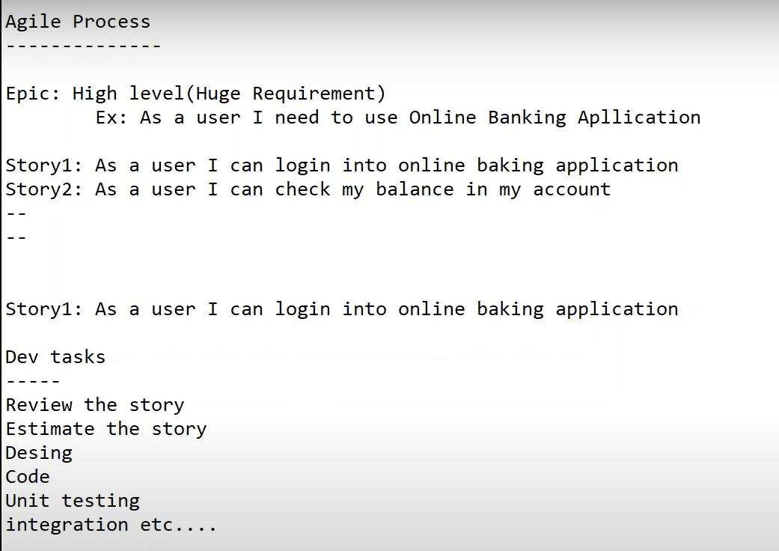

Scrum roles

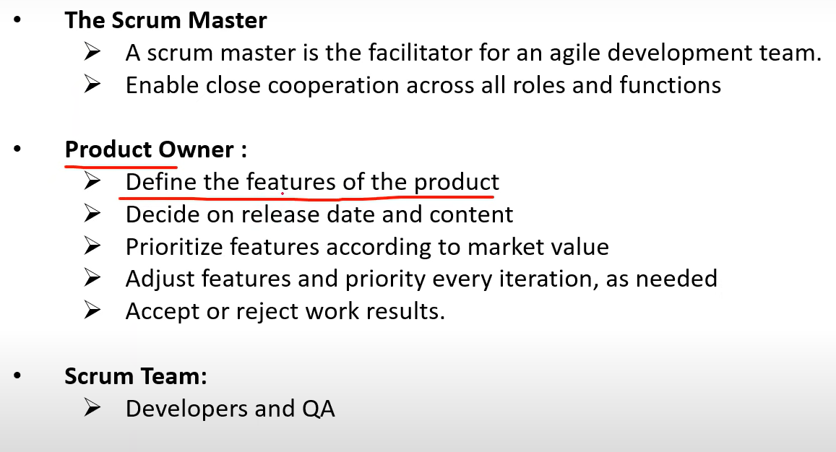

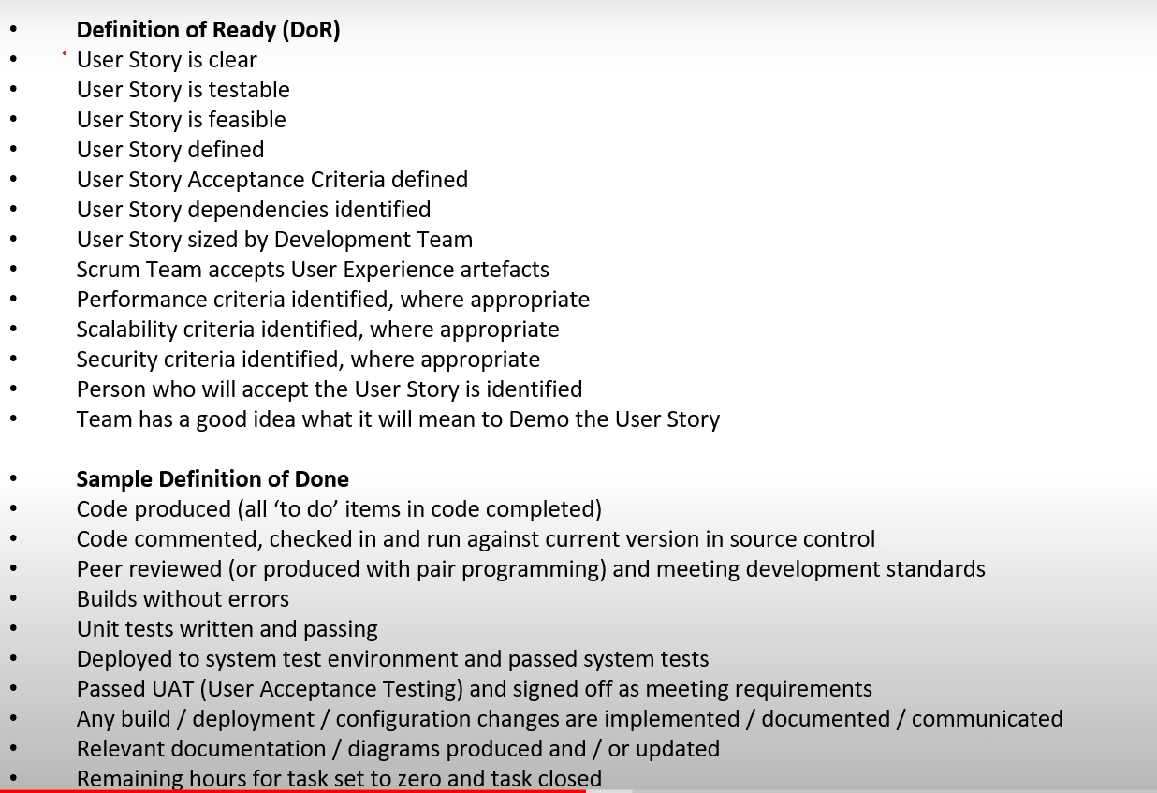

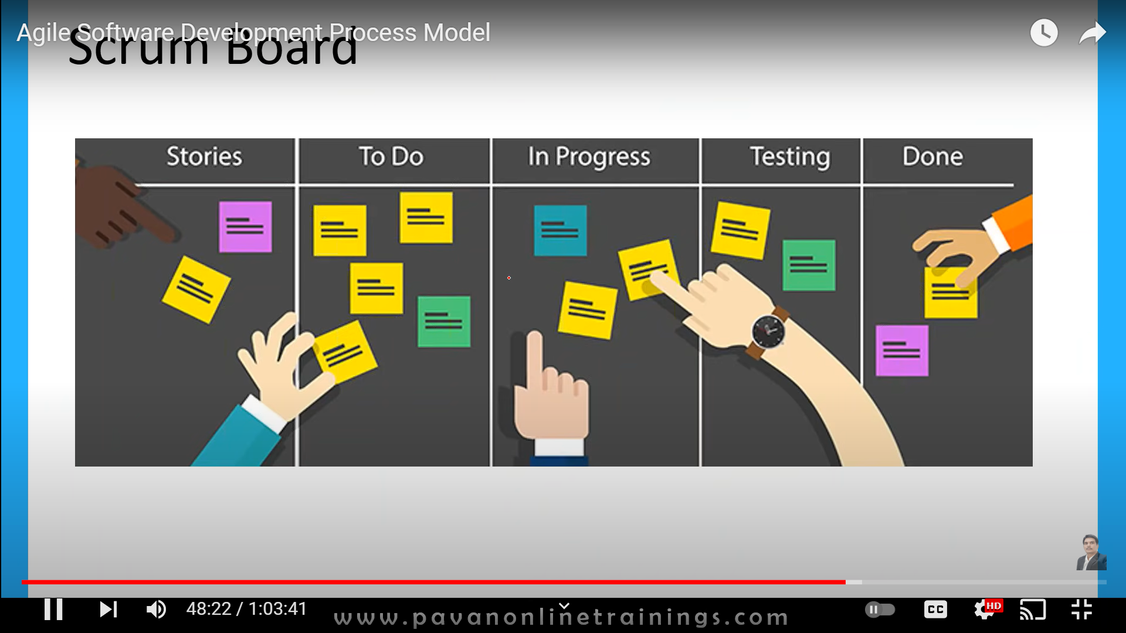

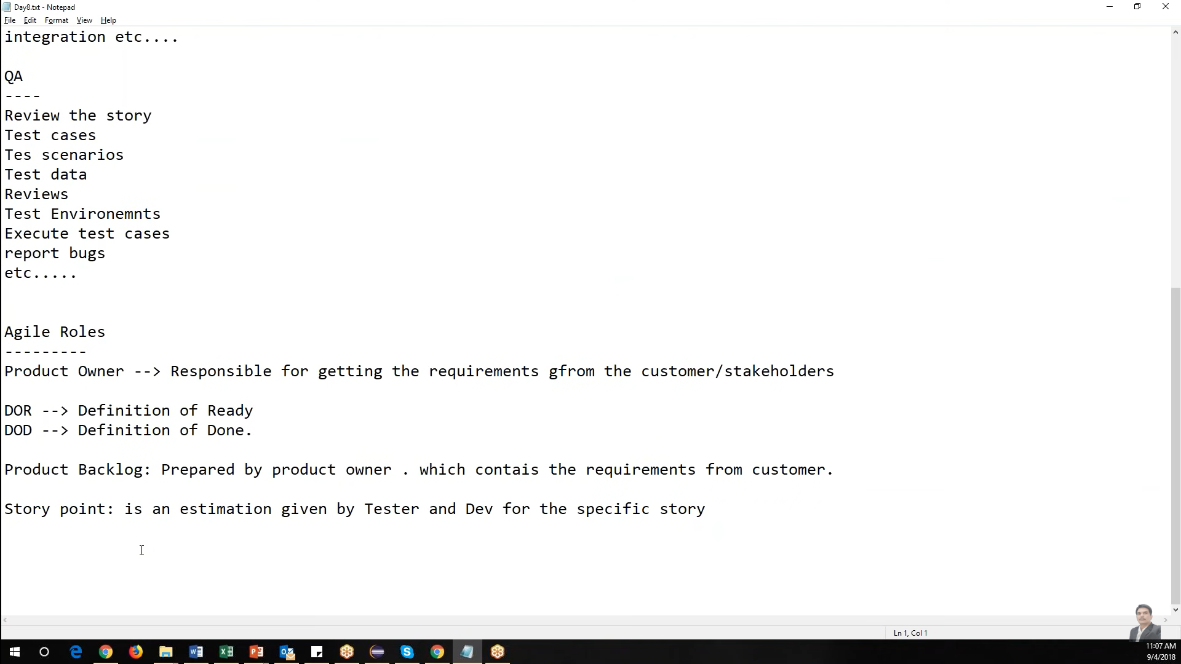

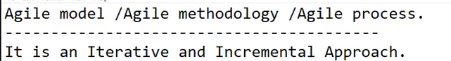

Iterative we are reaptingthe same steps again and again ( analyse,design , code, test)

Increment : Select few features in the beginning, then go on increment/ adding other features.

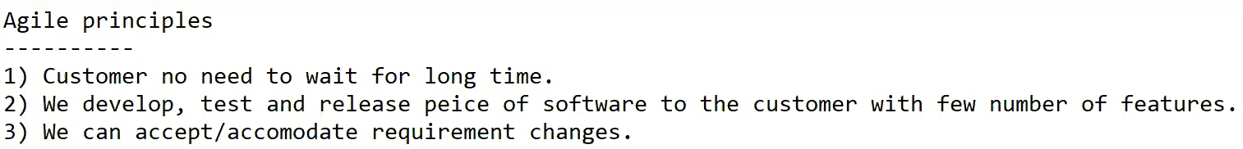

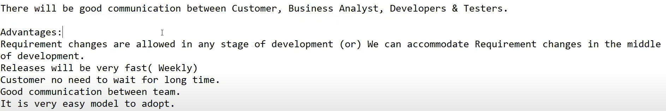



Scrum is a framework through which we build s/w product by following agile principles.

Scrum team

Product owner

Scrum master

Dev team

QA Team

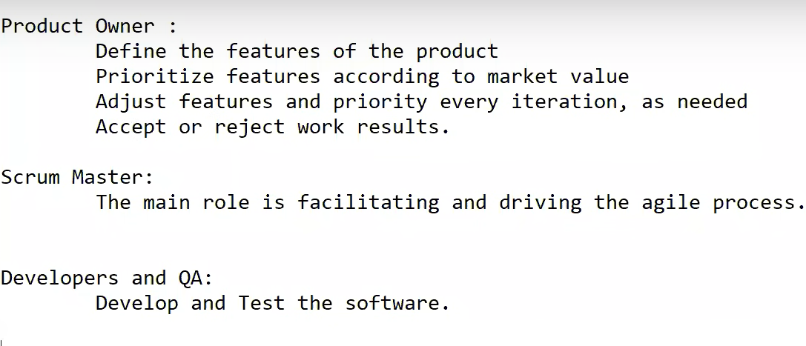

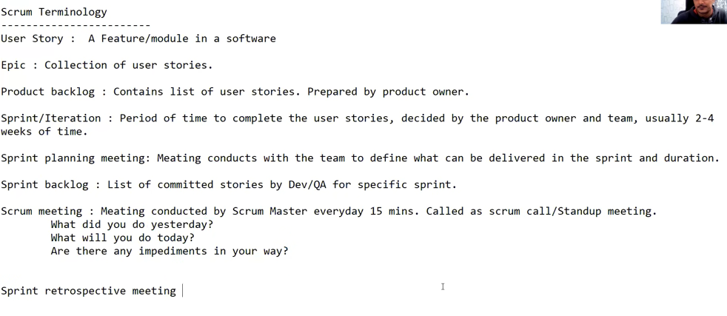



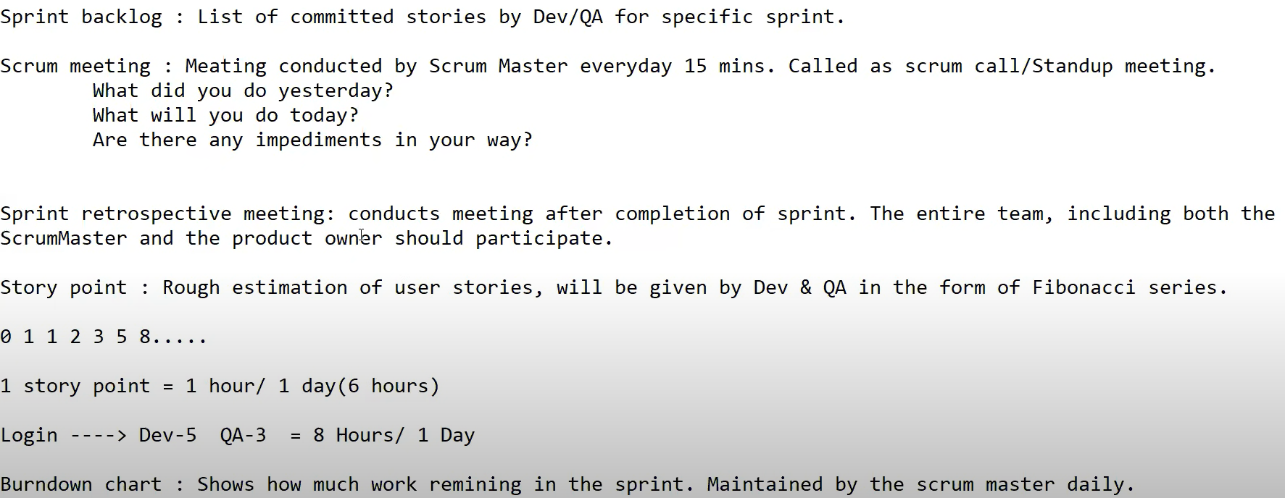

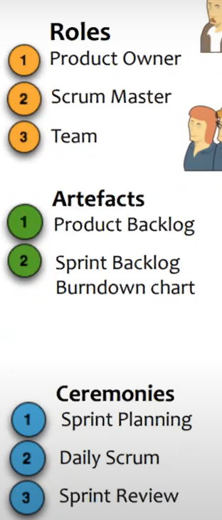

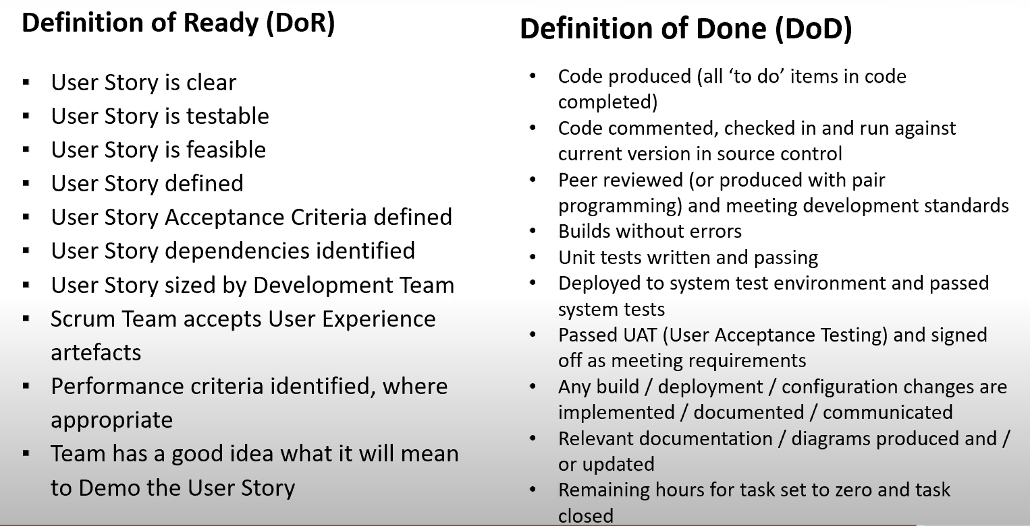

Sample product backlog

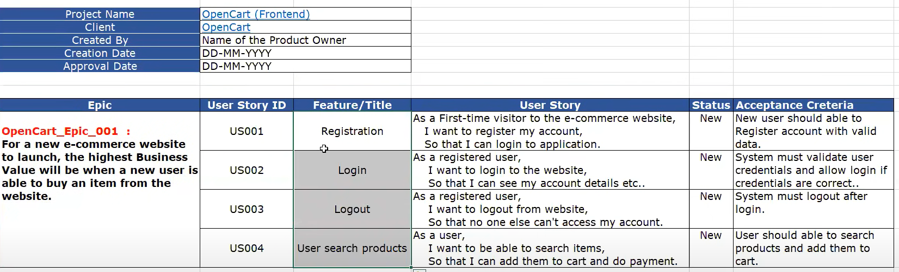

Sample Sprint backlog

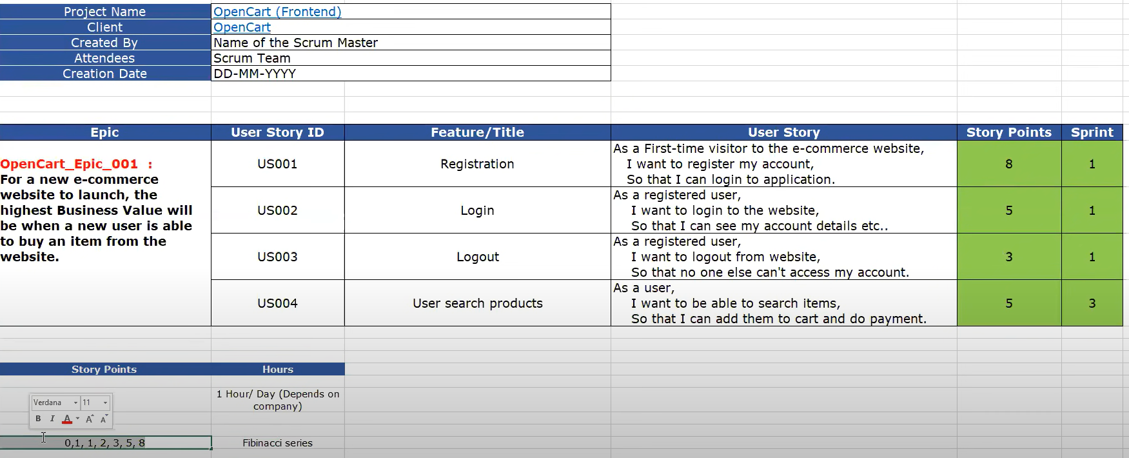

Tasks

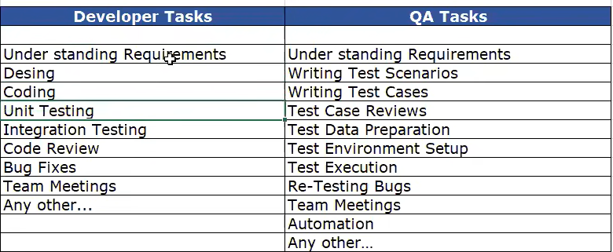

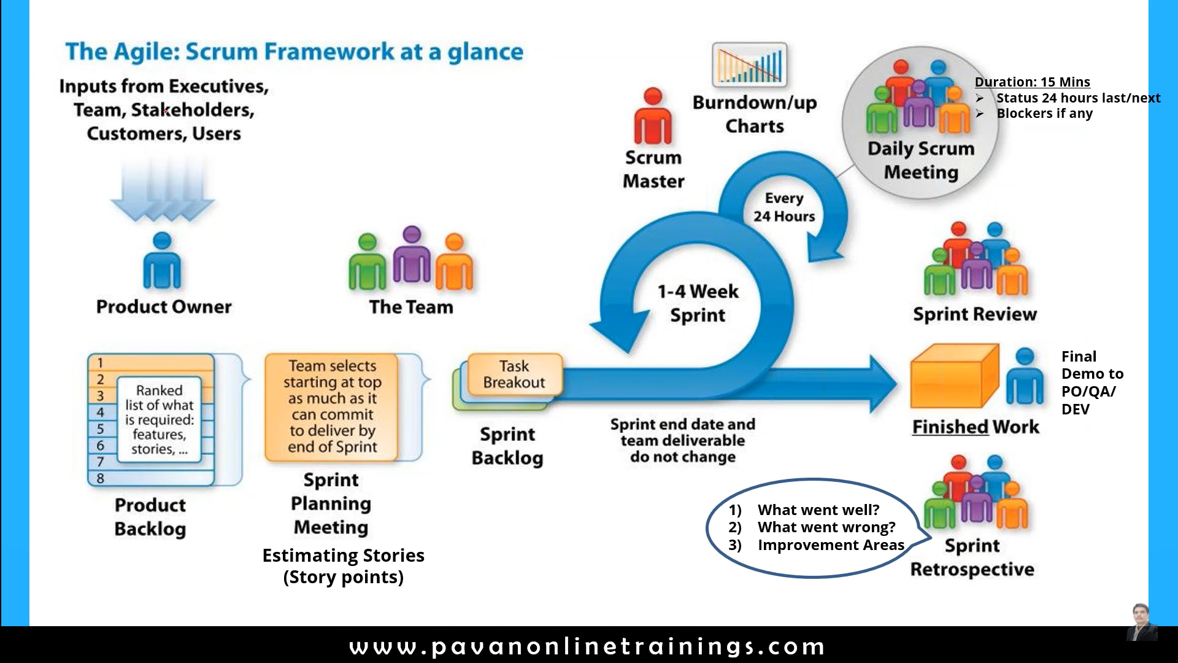

^^^^^^^^^^^^^^^^^^^^^^^^^^^^^^^^^^^^^^^^^^^^^^^^^^^^^^^^^^^^^^^^^^^^^

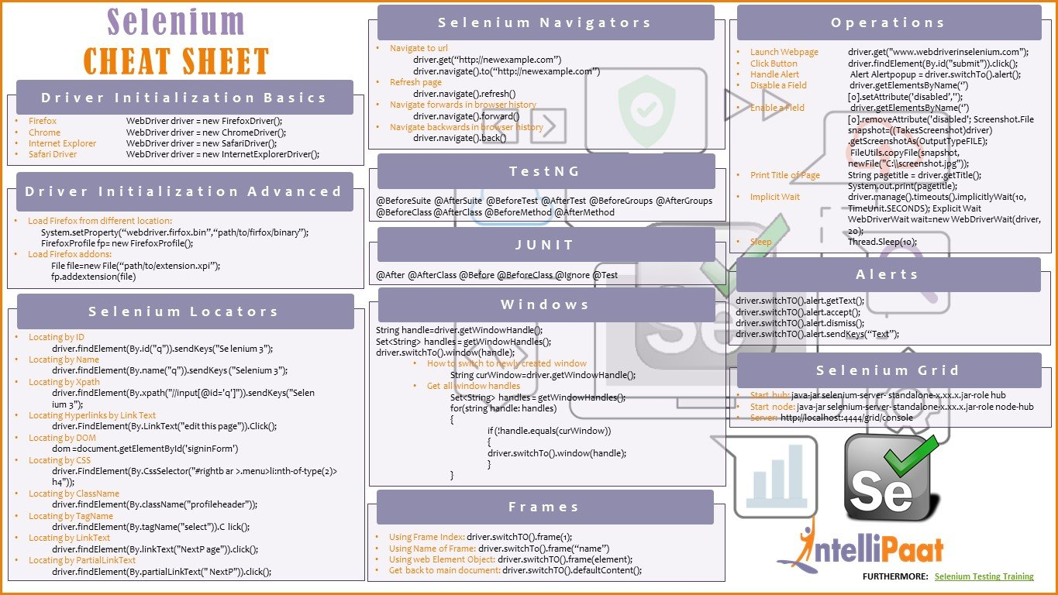

**^^^^^^^^^^^^^^^^^^^^^^^^^^^^^^^^^^^^^^^^^^^^^^^^^^^^^^^^^^^**

**Jira**

Jira is agile management tool. By adding the Zephyr plugin it provides test management tool.

What is JIRA?

JIRA is a software testing tool developed by the Australian Company Atlassian. It is a bug tracking tool that reports all the issues related to your software or mobile apps. The word JIRA comes from the Japanese word, i.e., "Gojira" which means Godzilla.

**What is a workflow?**

Workflow is defined as a movement of the bug/issue through various stages during its life-cycle

Created/Open

WIP ( Work In Progress)

Completed/Closed

**What can be referred to as an issue in Atlassian JIRA?**

In JIRA, an issue can be anything like a

Software bug

The project task

A help-desk ticket

The leave request form

**Agile Scrum activities in Jira**

1.Create project (Project menu 🡪 create project)

2.Add user/ people (Settings 🡪 User management , then provide emails of team)

3.Create backlog -Epic ( Project menu 🡪 backlog (left side bar))

Click on the version->create version, next provide version, description, start and end date

Click ob Eplc -> create epic, next provide epic name summary, reporter -> check create another if u want to create another epic🡪 create

* Epic is collection of stories.
* Story is a mall requirement

4.Create stories (click on Create🡪next select Story 🡪provide , summary and description 🡪reporter🡪 assignee 🡪 priority 🡪 label 🡪 epic link 🡪 sprint. Next click Create

5.Add story points (Under the backlog section 🡪 select the story 🡪 add story points)

6.Create sprint (Click on create sprint button 🡪 Drag and drop user stories to the sprint area )

7.Adding user stories to sprint

8.starting sprint (Click o start sprint button)

9.Adding sub tasks (Dev and QA will define the subtask. Select the user story 🡪 create task-> assign to the user. You can move the sub task to in progress or done – drag and drop or you can select the task and change the status )

10.Sprint life cycle ( to do 🡪 In progress 🡪 done)

11. Create test case in Jira manually (Install zyphre plugin) (Click on app 🡪 search for Zephyr scale 🡪 click-> try it. search 🡪 Zephyr Squad - Test Management for Jira 🡪 Try it) (Now you can create test as a issue,. If test is not visible then go to project settings and enable Zephyr )

To create test --> click on zephr 🡪 create test on click on “create” button

provide 🡪test case, test data, test result 🡪 click on tick mark

To add the test to the sprint 🡪 search test

Select the test=> click on the test -> test details

Test management activities (you need to install zephyr plugin)

1. Test cases
2. Test cycle
3. update test cases passed/failed/blocked
4. Report bugs
5. Generate reports

* Write test case Main page 🡪 zephyre 🡪 create test)
* Manually add test case -> Select the test 🡪 click on test details )

12. Import multiple test cases (Main page🡪 your project 🡪 zephyre 🡪 import test cases)

* Import test cases: Create test cases in excel by following the jira templete🡪 Click on project 🡪 zephyr squad🡪 Import test case -> choose the excel file -> when success🡪 Next

Start Row number = 2

Discriminator -> change of test case

Next

Do the jira columns to excel column mapping

click on Next 🡪 click on validate

When mapping is successful

click on begin import

To verify go to Zephyr sqad 🡪select test case

13. Creating test cycles

* Select project🡪Zephyr squad 🡪 cycle summary
* Click on create new test cycle
* Provide all the details and click on Save

14. Add test case to the cycle

* Once the test cycle is created. We need to add test cases to test cycle
* Next go to test case -> select a particular test case 🡪 Click on add to test cycle 🡪 select the test cycle ->assign it to user

Or

* Select the cycle summary 🡪 click on Add tests button 🡪 provide the test case name

You can verify by clicking on cycle summary

Report the bug by creating a issue 🡪 Issue type =”Bug”

15. execute/update test case

* Click Zephyre squal 🡪 search test execution -> Select the test case 🡪 click on test execution icon 🡪 Go the status and update the status

16 reporting bugs

* Click on Create button 🡪 issue type =”Bug”
* Click on “Issues” to see all the issues

16 .Reports in zephyre

* Back to project 🡪 click on Reports 🡪 select the type of chart
* To see test related reports 🡪 Zephyr 🡪

17. Traceablility matrix

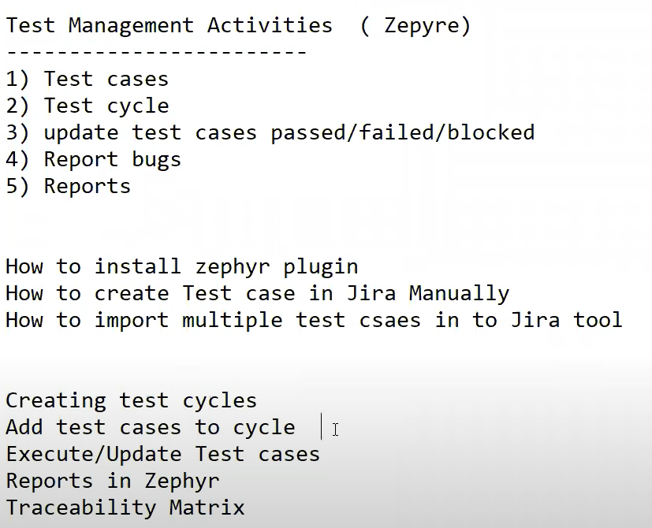

Adding test cases to test cycles :

The test has created /imported the test cases.

Then create e test cycle ex: regression cycle

Now add the test cases to regression cycle

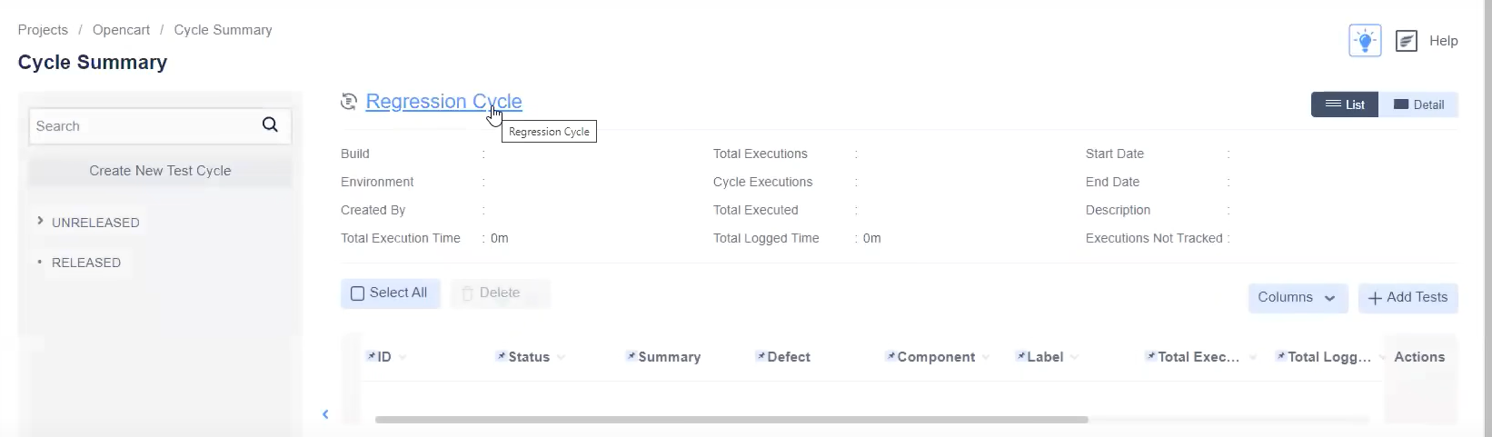

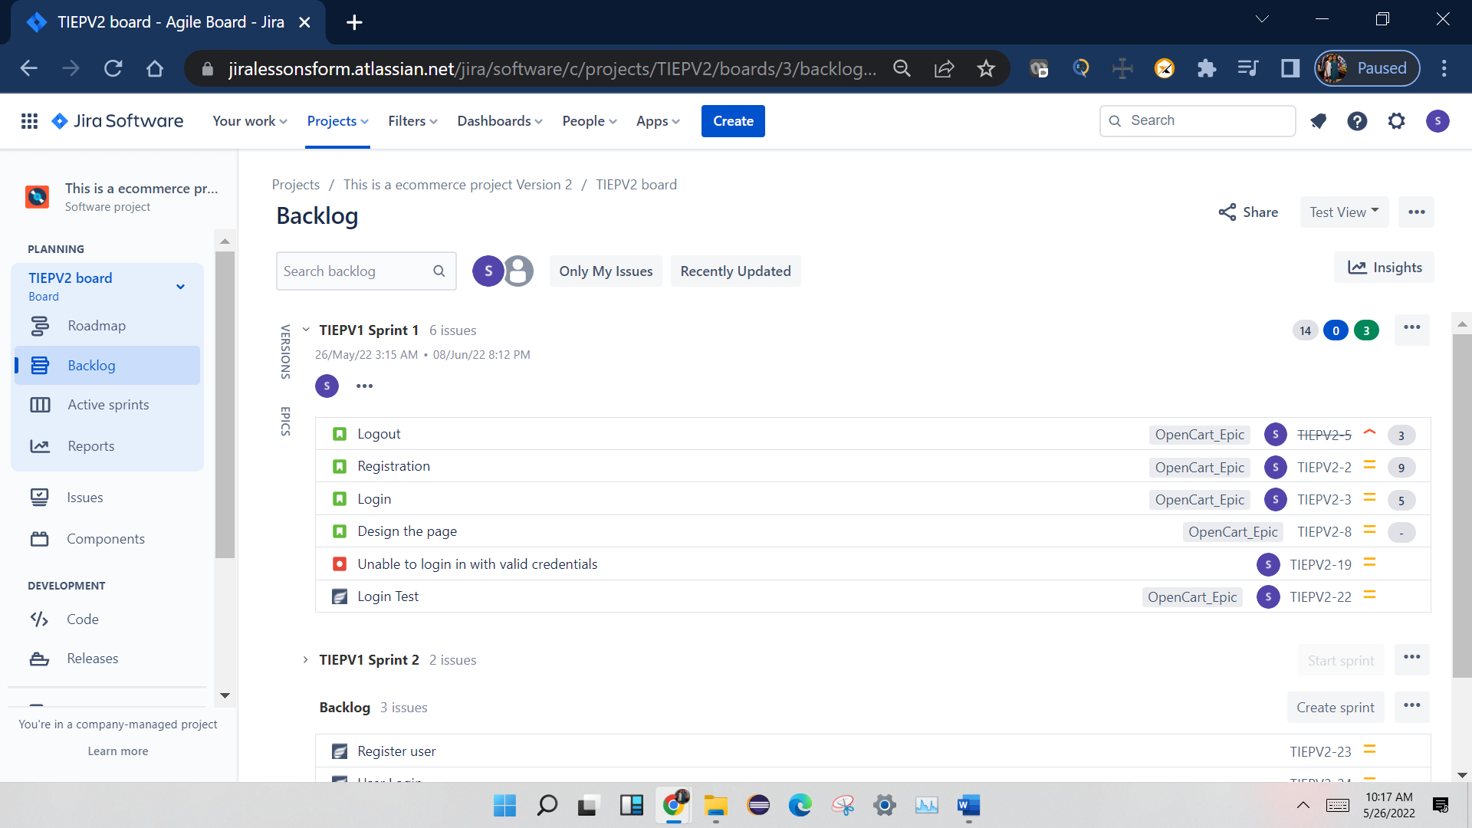

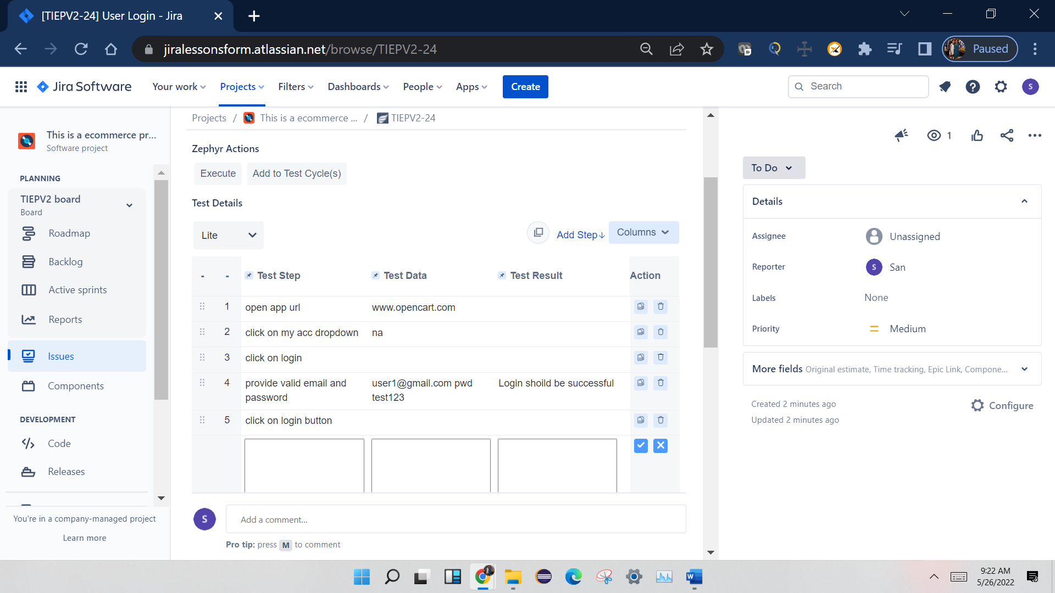

### Burn up vs. burn down chart — What is the difference?

A burn up chart and a burn down chart are both popular [project management](https://www.wrike.com/teams/marketing-project-management/) tools for visually tracking work completed over time. But, there are key differences between the two charts.

First, a burn down chart starts with the total amount of work and then graphs the amount remaining over time. As time progresses, the amount of work to be done lessens, and the line decreases toward the right.

A burn up chart tracks the amount of work to be completed as one straight line across the top of the graph (unless [a scope change](https://www.wrike.com/project-management-guide/faq/what-is-scope-creep-in-project-management/) occurs). A second line is then used to track work completed, starting at zero and increasing to the right as more tasks are finished.

Because of this difference, a burn down chart is great at emphasizing what’s left to be completed, but a burn up chart is better at illustrating the work that’s been accomplished.

**Javatpoint**

<https://www.javatpoint.com/agile-interview-questions>

# Top 20 Agile Interview Questions and Answers

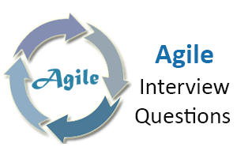

Here, we are giving the most relevant **Agile Scrum interview questions with answers** and hope these questions will help you while preparing for the agile scrum interview.

### 1) What is an agile or agile methodology?

Agile is an iterative approach of software development methodology using short iterations of 1 to 4 weeks. Due to the agile methodology, the development process is aligned to deliver the changing business requirement.

### 2) What are some quality strategies of agile?

Some quality strategies of agile are:

* Iteration
* Re-factoring
* Dynamic code analysis
* Short feedback cycles
* Reviews and inspection
* Standards and guidelines
* Milestone reviews

### 3) What are an agile manifesto and its principle?

Agile manifesto uncovers the better way of developing software by doing it and helping others to do it. Agile has 4 manifesto and 12 principles which defines:

* Individuals and interactions, i.e., self-motivating and self-organized should be encouraged.
* Demonstrate the working software at regular intervals with comprehensive documentation.
* Customers are collaboration over contact negotiation.
* Responding to change over following a plan.

AD

**The principles of agile manifesto are-**

1. **Customer Satisfaction:** Manifesto provides high priority to satisfy the costumer's requirements. Customer satisfaction is done through early and continuous delivery of valuable software.
2. **Welcome Change:** Making change during software development is common and inevitable. Every changing requirement should be welcome, even in the late development phase. Agile process is used to increase the customer's competitive advantage.
3. **Deliver the Working Software:** Deliver the working software frequently, ranging from a few weeks to a few months with considering the shortest period.

[Read more](https://www.javatpoint.com/agile-manifesto)

### 4) Is there any disadvantage of the agile model (SDLC)?

Disadvantages of Agile SDLC:

1. The development team should be highly professional and client-oriented.
2. New requirement may be a conflict with the existing architecture.
3. With further correction and change, there may be chances that the project will cross the expected time.
4. There may be difficult to estimate the final coast of the project due to constant iteration.
5. A defined requirement is absent.

[Read more](https://www.javatpoint.com/agile-sdlc)

### 5) What are the burn-up and burn-down chart?

The burn-up chart depicts the amount of work done in the project, whereas the burn-down chart illustrates the amount of work remaining in the project. Thus, the burn-up and burn-down are used to describe the progress report of the project.

### 6) What do you understand by Daily Stand-Up?

The daily stand-up is the day-to-day meeting (mostly in the morning) in which the whole team meets around 15 minutes to find the answer for the following three questions:

* What was done yesterday?
* What is your plan for today?
* Is there any obstacle that restricts you to complete your task?

### 7) What do you understand about Scrum?

**Scrum is a framework** that helps agile teams work together to develop, deliver, and sustain the complex product in the shortest time. The product provides by scrum team in this shortest period is known as a **sprint**.

### 8) What are the different roles in Scrum?

There are three different roles in scrum. These are the Scrum Master, Product Owner, Agile Development Team:

* **Scrum Master:** The Scrum Master is a team leader and facility provider who help the team member to follow agile practices so that they can meet their commitments and customers requirements.
* **Product Owner:** The Product Owner is one who runs the product from a business perspective. He defines the requirements and prioritizes their values.
* **Agile Development Team:** Agile development team provides the judgment on the technical feasibilities or any dependencies.

### 9) What are the responsibilities of the Scrum Master?

The critical responsibility of Scrum Master includes:

* Tracking and monitoring project development.
* Understanding the user requirement correctly.
* Work to obtain the project properly.
* Improving the performance of the team.
* Organized meetings and resolve issues.
* Communicate and report to the customer and development team.

### 10) What are different ceremonies and their importance in Scrum?

To clearly express the Scrum planning, Scrum review, Scrum Daily stand up, and scrum retrospective is the purpose of the ceremony. The importance of these ceremonies is to use sprint as per your project.

### 11) What do you know about Scrum ban?

Scrum-ban is a Scrum and Kanban-based model for software development. This model is used in the project that needs continuous maintenance, various programming error, or some sudden changes.

### 12) What do you understand by the term agile testing?

The agile testing is the software testing process which is fully based on the principle of agile software development. It is the iterative approach where the user story becomes the output of the collaboration between the product owner and the development team.

### 13) What are the major principles of agile testing?

Some of the essential principles of agile testing are:

* Customer satisfaction
* Face to face communication
* Sustainable development
* Continuous feedback
* Quick respond to changes
* Successive improvement
* Self-organized
* Focus on essence
* Error-free clean node
* Collective work

### 14) What are the skills of a good agile tester?

The agile tester is one who implements the principle of agile software development principles for software testing. An excellent agile tester has the following skills:

* He must be familiar with the principles and concept of agile.
* He must be excellent communication skill to communicate with the team and the clients.
* He can set the priority of a task according to customer requirements.
* He should able to understand the customer requirement properly.
* He should understand the project risk due to changing demand.

### 15) Name the agile frameworks.

Some of the agile frameworks are:

* Scrum
* Kanban
* Feature Driven Development
* Test Driven Development

### 16) Is it ever suggested to use waterfall over Scrum? If yes, explain when.

Yes, sometimes we use waterfall module over scrum. This is because when the client requirement is simple, small, well-defined, fully understood, predictable, and the subject does not change until the project complete.

### 17) Name some methodologies and development where you have used the agile model.

While answering this type of question, keep in mind to mention those methodologies from which you are familiar whit. Some of the methodologies where agile is used are:

* Crystal methodologies
* Lean software development
* Dynamic development
* Feature-driven development

### 18) What was the length of sprints/iterations in your project?

It is a common question for experienced people. The idea behind is to judge in which kind of environment you have worked? There will be follow up of the question that the length fixed in the beginning and never changed? Did you try with less than this length or more than that?

### 19) What is the difference between the agile & traditional way of working?

The traditional way of development is that which follow the sequential where design -> development -> testing etc. is performed whereas, in agile development, all of this is done in every iteration/sprint.

### 20) Why does Scrum encourage the use of automated testing for projects?

Due to faster possible delivery of the project, the Scrum development encourages to use automated (automated performance or automated regression) testing. While answering this question, you should explain some tools that you have used for automated testing.

^^^^^^^^^^^^^^^^^^^^^^^^^^^^

[Software Testing Help](https://www.softwaretestinghelp.com/)

<https://www.softwaretestinghelp.com/agile-interview-questions/>

### Top Agile And Scrum Interview Questions

Let’s start with the top Agile Scrum Methodology interview questions.

**Q #1) How long the Scrum cycle last?**

**Answer:** Basically, the Scrum cycle depends on the project size and team size. Team size may vary from 3 members to 9 members.  Normally, it takes 3 to 4 weeks to complete a Scrum sprint. On an average, a scrum sprint ends in 4 weeks.

**Q #2) What is the scrum of scrums?**

**Answer:**Suppose there are  7 teams working on a project and each team has  7 members. Each team leads its own particular scrum meeting. Now to coordinate among the teams a separate meeting has to be organized, that meeting is called Scrum of Scrums.

[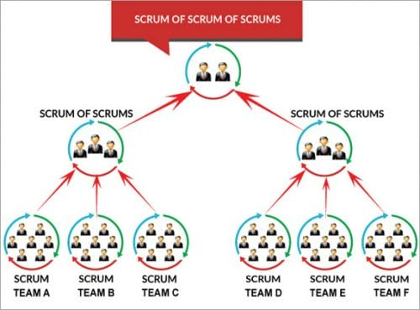](https://www.softwaretestinghelp.com/wp-content/qa/uploads/2017/11/Scrum-of-Scrums-e1509975592287.jpg)

An ambassador (a designated person who represents team) represents its team in the scrum of scrums.

**Few points discussed in the meeting are:**

1. The progress of the team, after the last meeting.
2. The task to be done before the next meeting.
3. Hindrance which the team had faced while completing the last task.

**Q #3) Explain the term ‘increment’?**

**Answer:**When the team finishes the sprint, hopefully, they have completed everything they forecasted. The sum of all the product backlog items which were completed in a sprint is called increments. This new increment also has the value of increment of the previous sprints.

**Q #4) What is Sashimi?**

**Answer:**Sashimi is a Japanese word that means a pierced body. Basically, it is a Japanese dish that consists of fresh meat or fish, sliced into thin pieces. Each piece is similar in taste when compared with the other pieces.

Sashimi in scrum methodology means every phase of the software development cycle in a sprint which includes requirement analysis, planning &  design, development, testing, documentation is complete or not and the product is ready to be displayed, etc.

**Q #5) What are impediments?**

**Answer:**Any hindrance which prevents the smooth flow of work or due to which the team is not able to perform its task in a better way is what we call ‘impediments’.

**Q #6) Explain ‘scrum poker’ or ‘planning poker’ technique?**

**Answer:**Scrum poker, also called as planning poker, is a card-based estimation technique which is based on a general agreement.

1. To start it, the agile user story is read either by the customer or the owner and the estimator understands its features.
2. Each estimator has planning cards with different no. on it like 0,1,2,3,5,8 and so on. These values on the card are ideal days or story points.
3. Estimator select cards based on their estimation by discussing features set by the product owner.
4. If a common value is selected, it is an estimate, if not they discuss their max. and min. estimation.
5. This process is repeated until a general agreement is reached.

**Q #7) What are the principles of agile testing?**

**Answer:** **Some major principles of agile testing are:**

* Customer satisfaction
* Bug-free clean code
* Changes are welcome by customer
* Whole team, business people and developers work collectively
* Instead of lengthy documentation, focus on the essence
* It focuses on face to face conversation
* It promotes sustainable development

**Q #8) What are the disadvantages of the agile model?**

**Answer: Some of the disadvantages of using the agile model are as follows:**

* Not easy to predict: When you encounter a large project, it is not easy to get an idea of how much effort will it require.
* If the guidelines given by the customers are not properly grasped, then final outcome of the project is not as per customer satisfaction.
* Sometimes focusing on design and documentation is not proper
* High-level decisions are under the hand of Veterans, if not combined with non-experienced ones, freshers have little scope to grasp proper knowledge.

**Q #9) When to use the agile model?**

**Answer:**There are some development and methodologies where you can use agile like feature-driven development, lean software development, crystal methodologies, dynamic development.

**Q #10) What is the Release candidate?**

**Answer:**The release candidate is a code /version /build released to make sure that during the last development period, no critical problem is left behind. It is used for testing and is equivalent to the final build.

**Q #11) In what way does agile testing(development) methodology differ from the other testing(development) methodologies?**

**Answer:**In [Agile methodology](https://www.softwaretestinghelp.com/agile-scrum-methodology-for-development-and-testing/), the code is broken into small parts and at a time, only that particular code is worked or tested. Continuous communication on the particular code part is done by a team so that the focus is only on that particular code. This makes the agile process more flexible and focused.

**Q #12) Can agile methodology also be applied in other than software testing and development projects?**

**Answer:**There are several places where agile methodology can be applied in the field of biochemistry, biophysics, bio-medical or at the place where there is insufficient data, where the project needs to be completed in a small team, where to work in unknown and there are several areas.

**Q #13) How do you know if you are using agile development?**

**Answer:**Whenever you are using certain things like test-driven development, time-boxed task board, class responsibilities collaborators, daily stand up meeting, pair programming, continuous integration, reviews and much more, you will get to know that you are using agile development

**Q #14) Explain what is a story point in the scrum?**

**Answer:**It can be considered as a unit to estimate the total efforts required to complete or to do the particular task or implementing a backlog.

**Q #15) What does the X and Y-axis of the burndown chart?**

**Answer:**In burn down, chart X-axis shows working days and Y-axis shows remaining efforts.

[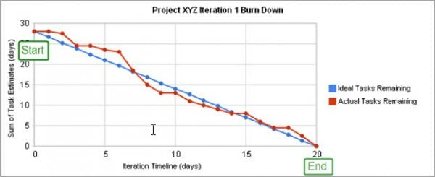](https://www.softwaretestinghelp.com/wp-content/qa/uploads/2017/11/Project-XYZ-e1509975673494.jpg)

Here, in the image blue line depicts the ideal time suggested for completing the project. **For Example,** in a project ideally, 28 tasks (efforts) are pending on the starting day of the project. And the project is scheduled to be completed in 20 days. So, on the 20th day, zero tasks (efforts) should remain, which means the project should get completed.

On the other hand, the red line depicts the actual task (efforts) given with respect to the days. Here on day 5, 7 tasks need to be completed as per planning, however, in actual only 4 tasks were completed.

Thus, it provides proper tracking down of the progress of the project and thereby helps in improving the efficiency and on-time taken to deliver the project.

**Q #16) What are the main roles in the scrum?**

**Answer:**

1. **Scrum Team**: Scrum team is made by an individual person who works collectively to achieve a particular task. The team works in a bond to deliver committed and requested products.
2. **Scrum Master**: Scrum Master is responsible for the proper execution or working of the scrum team. Being a servant – leader and a coach, he ensures the proper productivity of a team towards scrum sprint goal.
3. **Product Owner**: The product owner has the responsibility to deliver a complete picture of what to build and to convey that idea to the team.

**Q #17) What is a product burndown chart?**

**Answer:**A description in the form of the graph which shows implemented and not – implemented product backlog is called the burndown chart.

**Q #18) What is the sprint burndown chart?**

**Answer:**A graph used to describe no. of implemented/non-implemented sprint in the Scrum cycle.

**Q #19) What is the Release burndown chart?**

**Answer:**The graph used to depict the pending release which was earlier planned is called Release burn down the chart.

**Q #20) What is the defect burn down chart?**

**Answer:** The number of defect identified and removed is represented by the**defect**burn down**chart.**

**Q #21) What is the sprint planning meeting?**

**Answer:**A sprint planning meeting is joined by all entities like scrum master, product owner and whole scrum team where they discuss the priority features of the team and product backlog items.

**Q #22) What is a Sprint Retrospective meeting?**

**Answer:**This is mostly the last part of the sprint or may be done after the sprint review meeting. [Scrum](https://www.softwaretestinghelp.com/agile-scrum-methodology-for-development-and-testing/) master and the whole team participate in it. They discuss ‘ what was good during the sprint’,’ what was bad’,’ what needs to be improved’. It generally lasts for 2-3 hrs.

**Q #23) What do you know about ‘build-breaker’?**

**Answer:**When sometimes developer accidentally commit bug in the software and when such bug stops the compilation process and generates the warning or failure in the normal execution of testing, we say that the build is broken and the major priority of the tester is to get back again to the normal stage by resolving the [bug](https://www.softwaretestinghelp.com/how-to-write-good-bug-report/) issue.

**Q #24) Tell me something about Kanban?**

**Answer:**Kanban is a tool that helps the team to overlook the work ie., its progress. Progress, as well as the status of your current development story, is perfectly described using kanban and more accurately it is done by the ‘Kanban board’.

Kanban board allows you to write the whole scenario of your project at a single place so that you can get a perfect picture of the bottleneck, a task done, workflow progress or basically the complete status of your project.

**Q #25) Describe the places where ‘Scrum’ and ‘Kanban’ are used?**

**Answer:**‘Scrum’ is used when you need to shift towards a more appropriate or more prominent process while if you want improvement in running the process without much changes in the whole scenario, you should use ‘Kanban’.

**Q #26) Why aren’t user stories simply estimated in man-hours?**

**Answer:**Estimation of user stories on the basis of man-hours can be done but preferably not. You won’t be able to concentrate on the quality product to be delivered to the customer. Moreover, you will concentrate on the cost and budget of the management while using man-hours.

Instead of that, one can use story points, as it provides the complete idea about both the complexity of work and required efforts

**Q #27) Name three other Agile frameworks?**

**Answer:**[Test Driven Development](https://www.softwaretestinghelp.com/testers-in-tdd-bdd-atdd-techniques/), Feature Driven Development, and Kanban.

**Q #28) Should scrum master remove impediments on behalf of the scrum team?**

**Answer:**Scrum master can do that, but he should not. The scrum master should neither over-rule nor pamper his/her team. Initially, there may be chances of failure, unplanned excursions or dead-end where the team can trap, here scrum master should support them and show the proper way of getting out of it. A scrum team should be independent to take its own decision.

**Also read =>>**[**Scrum Master interview questions and answers**](https://www.softwaretestinghelp.com/scrum-master-interview-questions/)

**Q #29) How does agile testing (development) methodology differ from another testing (development) methodologies?**

**Answer:**In agile testing methodology, the entire testing process is broken into a small segment of codes and in each step, these codes are tested. There are several processes or plans involved in this methodology like [communication](https://www.softwaretestinghelp.com/how-to-improve-communication-skill/) with the team, short strategical changes to get the optimal result, etc.

**Q #30) How would master recommend following-up on action items?**

**Answer:**The best way of doing that is by setting a follow-up of the task/list to be done by the member pick at team retrospective. The scrum master should collect the information or status of the action items from the previous retrospective before moving further with the new one and if any of the action items remain uncovered or untreated, the cause or the reason should be known to avoid it’s further happening.

**Q #31) Which are the top agile matrices?**

**Answer:**

1. **Velocity**: Tracking your velocity gives you a clear idea about your progress, capacity, etc. Measurement can be done by the sum of all approved estimates of the stories.
2. **Work category allocation**: This factor provides us a clear idea about where we are investing our time or where to set priority.
3. **Defect removal awareness**: Quality product can be delivered by active members and their awareness
4. **Cumulative flow diagram**: With the help of this flow diagram, the uniform workflow can be checked, where X-axis shows time and Y-axis shows no. of efforts.
5. **Sprint burndown matric**: Tracking on the completion of work along with the sprint is done.
6. **A business value delivered**: Business value delivered is an entity that shows the team’s working efficiency. This method is used to measure, in which around 100 points are associated with each project. Business objectives are given value from 1,2,3,5 and so on according to complexity, urgency, and ROI.
7. **Defect resolution time**: It’s a process where team member detects the bug and priority intention by the removal of the error. **A series of process is involved in fixing the bug:**
   * Clearing the picture of a bug
   * Schedule fix
   * Fixation of Defect is done
   * Report of resolution is handed
8. **Time coverage**: Amount of time given to code in question in testing. It is measured by the ratio of no. of the line of code called by test suite by total no. of the relative lines of code (in percentage).

### Conclusion

Agile methodology is designed to complete the task in the shorter time slot, which precisely satisfies the needs of the client and at the same time scrum is famous for its flexibility according to the requirements.

**In this article, we have touched the top Agile interview questions which are most popular and frequently asked.** This, in turn, will surely benefit you from the point of an interview as well as brushing your Agile and Scrum knowledge.

All the best !!!

javaTpoint start—jira

JIRA Interview Questions

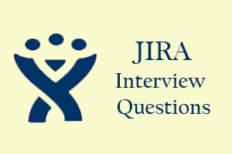

A list of frequently asked **JIRA Interview Questions and Answers** are given below.

1) What is Jira?

* Jira is a software testing tool developed by an Australian company, i.e., **Atlassian**.
* It is a bug tracking tool used to track the issues and bugs related to your software and Mobile apps.
* The name "**Jira**" comes from the Japanese word "Gojira", which means **Godzilla**.
* Jira is based on Agile methodology, and the current version of Jira is 6.

2) Explain Jira workflow.

Jira workflow is a set of activities performed to track and transition of an issue during the lifecycle of an issue where transition represents the link between the two statuses when an issue moves from one status to another status, and status determines the impact of the work on an issue filed by the tester.

**The following are the phases that occur in a workflow:**

* **TODO**
* **In Progress**
* **Done**

AD

The Jira workflow is known as **defect lifecycle** or **bug lifecycle**. The bug lifecycle consists of the following phases:

* **Open issue**  
  When the issue is created by the tester, then the issue is assigned to the software developer, and they start working on it.
* **In Progress**  
  This is the phase where the software developers start working on the issue.
* **Resolved issue**  
  When the issue is resolved by the software developer and waiting for the verification by the software tester. If the verification is successful, then the issue is closed; otherwise, the issue gets reopened.
* **Reopened issue**  
  If the verification is unsuccessful, then the issue is reopened and assigned to the software developer.
* **Close issue**  
  If the verification of the fixed bug is successful, then the issue is closed by the tester.

3) Explain the report types generated by Jira.

Jira is a defect tracking tool that creates different reports which allow you to get an overview of the current status of a project.

JIRA report is a pictorial representation of the current status of a project in the form of charts, line-charts, bar-graphs, etc.

**The following are the reports generated by Jira:**

* **Average Age report**  
  The average report is a bar chart that displays the average age of unresolved issues for a project or filter.
* The Average Age report is generated that depends upon the selected project, the type of issue selected in the filter, and time is chosen (hours/days/week/months).
* **Created vs. Resolved Issues report**
* The created vs. resolved issues report displays the difference chart between the number of issues created and the number of issues resolved within a timeframe.
* **Pie chart**

The pie chart is used to display the issues grouped by a specified field, and the specified field can be priority, assignee, project, issue type, etc.

* **Recently created issue report**

The recently created issue report represents a chart that shows the rate at which the new issues are created and how many issues are resolved during the same interval.

* **Resolution Time Report**

The resolution time report determines the length of the time taken to resolve the issues for a project/filter.

* **Single Level Group by the Report**

The single-level group by the report does not display the chart, but it categorizes the issues grouped by a particular field for a filter.

* **Time Since Issue Reports**

The time since the issue report is a bar chart that shows the number of issues of a particular data field which was set on a given date. Suppose I choose the "Created" as a data field then the bar chart shows the number of issues which are created.

4) Explain the process of how an issue is generated in Jira.

**The following are the steps to create an issue:**

* Click on the '+' button to create an issue. On clicking on the '+' button, the screen appears which is shown below:

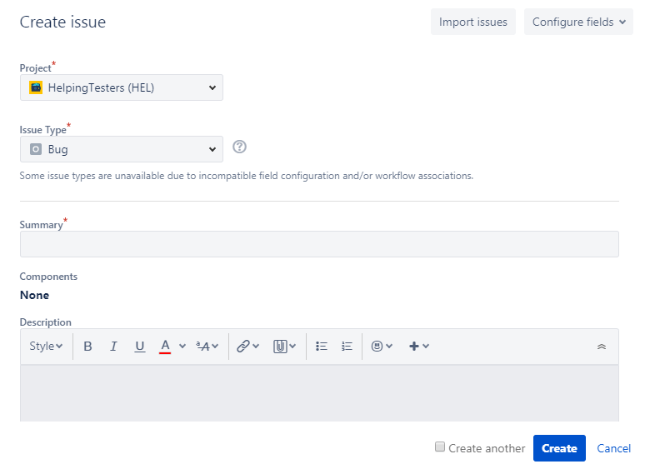

**Project:** It determines the name of the project.  
**Issue Type:** It is a dropdown which displays the lists of all the issue types. You can choose either of them such as Bug, epic, task, sub task.  
**Summary:** In the summary text field, you need to type the summary related to the issue that you are creating.  
**Priority:** You can set the priority of an issue. It can be either medium, high, low.

When you fill all the details related to your issue, click on the create button.

5) What is the way with which an issue can be shared with other users in Jira.

An issue can also be shared with other users in Jira. The following are the steps required to share an issue with other users in Jira:

* **Suppose we have an issue that already exists in Jira, i.e., the login button is not working.**

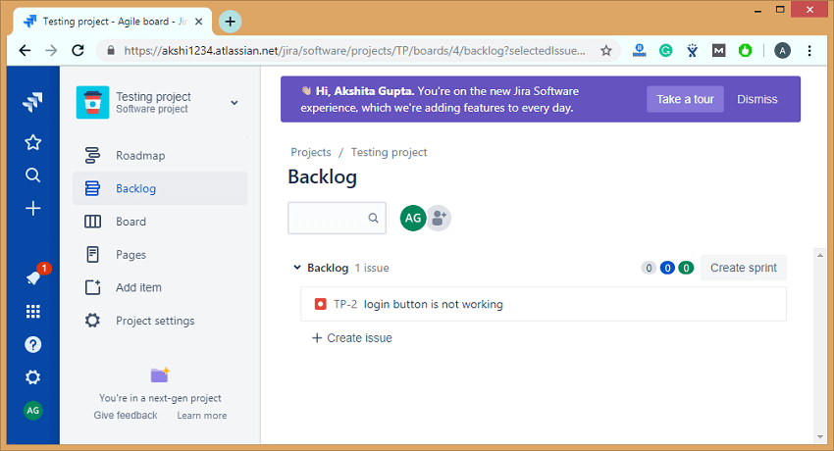

The above screen shows that an issue "**TP-2 login button is not working**" has been created.

* If we want to share the issue, then this can be achieved by using the share option available on the issue's description, it can be shown in the below screenshot:

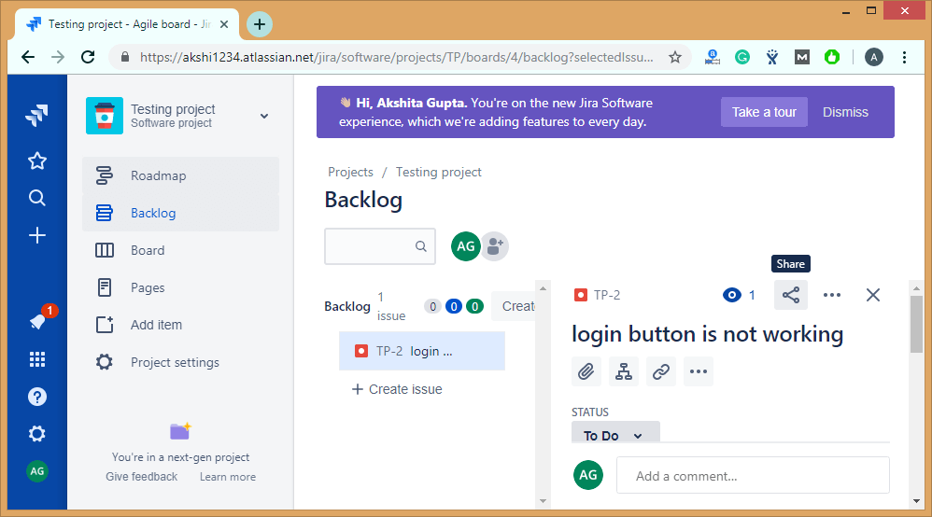

* Click on the **share** shown in the above screenshot. On clicking on the **share**, the screen appears shown below:

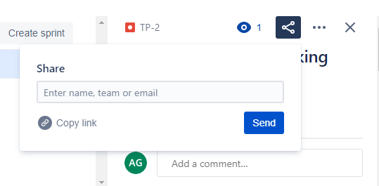

The above screen shows that the dialog box appears on clicking on the share button, and in a dialog box, you need to enter the name, team or email address of a user to which you want to share your issue.

6) What is the purpose of Dashboard?

Once you log in to the Jira, Dashboard is the first display which you see. Jira admin can change the view of the dashboard, and also you can change the things that are visible on the dashboard.

A dashboard displays gadgets and apps that help the team members to track the project's progress.

The dashboard contains useful information, such as the issues assigned to the logged-in user and the user's activity stream.

On clicking on the Dashboard link appearing at the left side of the panel, the page appears which is shown below:

AD

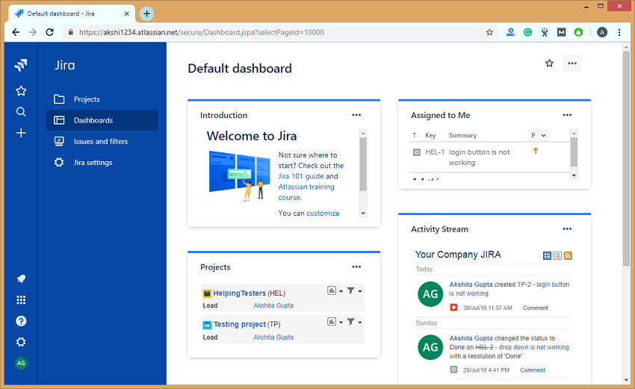

**Following are the steps required to create a Dashboard:**

* Click on the Dashboards appearing on the left side of the panel.
* Click on the (...) button appearing at the top right corner of the page.

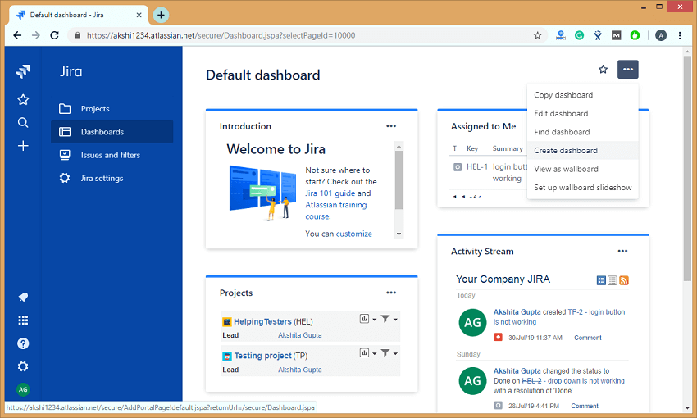

* Click on the Create dashboard option appearing in the dropdown menu of (...) option.
* On clicking on the Create dashboard, the screen appears, which is shown below:

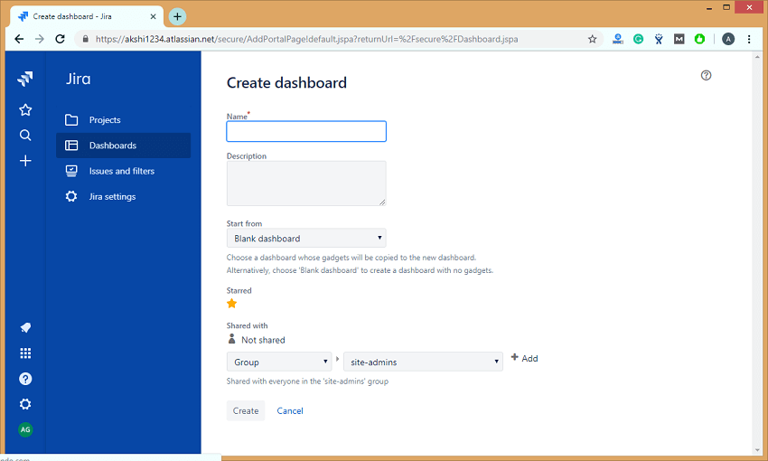

Where,

**Name:** It provides the descriptive name of a dashboard.

**Description:** It is not a mandatory field. In this field, you can add the description of a dashboard that you are creating.

**Start from:** Start from is a field that contains the dropdown in which you can choose either Blank Dashboard (It is a blank dashboard which does not contain any gadgets, but you can customize the dashboard according to your needs) or Default dashboard (It is pre-existing dashboard).

**Shared with:** Select the user and group to which you want to share your Dashboard.

7) What do you mean by scheduling an issue?

We can schedule the issues due dates which are used to track, review, and inform the team about due dates. Scheduling an issue is the most powerful feature that performs the fixed and relative date searches based on the due dates.

Advanced searches can also be performed by using the Jira Query Language.

You can schedule an issue by using the Date field. It can be done either by creating a new issue or editing an issue.

8) Explain how project details are listed in Jira?

Project in Jira comes with the main attributes, and these attributes can be a Name of the project, key, components, versions.

When you log in to the Jira, the first page that appears is the Dashboard.

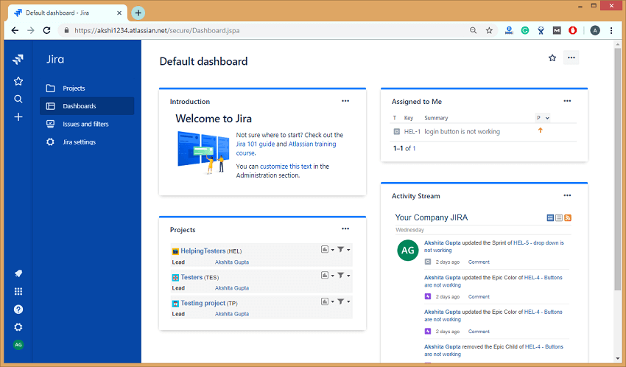

In the above screen, the right-hand side section represents the **Activity Stream** that contains all the activities which you performed on an issue or a project.

9) What are the issue types that are created and tracked via JIRA?

An issue in Jira can be a bug, feature, task, or any project work. Each Jira project comes with default issue types, and these issue types depend on the type of project that you are using.

**There are three types of Jira projects:**

* **Jira Core (business projects)**
* **Jira Software (software projects)**
* **Jira Service Desk (service desk projects)**

**Two types of issue exist in Jira Core:**

* **Task**  
  The task is a work that needs to be completed.
* **Subtask**  
  Subtask is a piece of work which needs to be done to complete a task.

**Five types of issue exist in Jira Software:**

* **Bug**  
  A bug is a problem that exists in the functionality of a product.
* **Epic**  
  Epic is a big user story which needs to be broken into smaller stories.
* **Subtask**  
  Subtask is a piece of work which needs to be done to complete a task.
* **Task**  
  Task is a work that needs to be completed.
* **Story**  
  The story is the smallest unit of work which needs to be completed.

**Eight types of issue exist in Jira Service Desk:**

* **Change**  
  It requests a change in a current IT profile.
* **IT help**  
  It requests for help related to an IT-related problem.
* **Incident**  
  It is used for reporting an incident.
* **New feature**  
  It requests for adding a new feature or capability in software.
* **Problem**  
  It is used for investigating and reporting the root cause of multiple incidents.
* **Service request**  
  It is requesting for help from an internal or customer service desk.
* **Service request with approval**  
  It is used for requesting help that requires the approval of a manager or a board.
* **Support**  
  It is used for requesting help for customer support related issues.

10) How is sub-task created in Jira?

**The following are the steps required to create a sub-task:**

**Step 1:** Open the issue for which you want to create the sub-task.

**Step 2:** Click on theicon to create a sub-task.

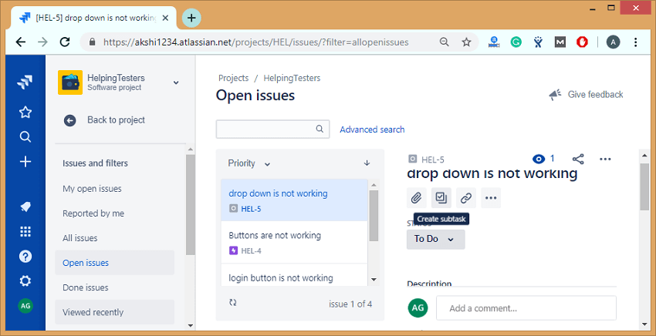

**Step 3:** To create a sub task, you need to enter the following screen shown in the below screen:

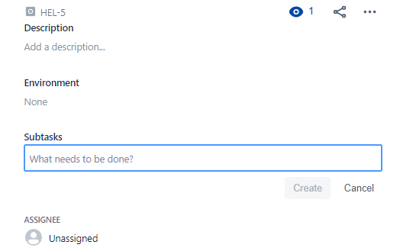

11) Explain the term cloning an issue?

* Cloning an issue means creating the duplicate copy of an issue within the same project. The clone issue is basically a copy of the original issue which is pertaining to the same information stored in the original issue.
* A clone issue is a separate entity from the original issue, but it can be linked to the original issue.
* Operations applied to the original issue will not have any effect on the clone issue

12) Explain Kanban board?

Kanban board is a tool used to visualize the work and limit work-in-progress.

As in scrum, we are taking some activities from a product backlog and adding in a sprint backlog. However, in Kanban, we do not have sprint, so sprint backlog activity will not be performed. This is the main difference between scrum and Kanban that scrum contains sprint backlog while kanban does not contain the sprint backlog.

**Kanban board consists of three states:**

* To Do
* Doing
* Done

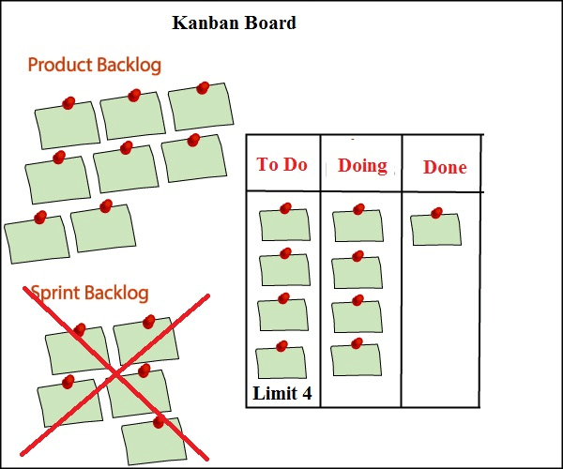

When the project is started, then we put all the activities from the product backlog to the '**To Do**' state. When the team member starts working on an activity, then that activity is put in a '**Doing**' state, and when the activity is placed, then it is placed in a '**Done**' state.

From the Kanban board, one can get to know which activities have been done and which activities they need to develop.

One of the most important features of the Kanban board is a **Limit** option. In the above figure, we have eight tasks in a product backlog and limit set is 4. At a time, it will take only four tasks in a '**To Do**' state, and if any of the tasks come in a '**Doing**' state, then one more task from the product backlog will be placed in a '**To Do**' state. In this way, we can set the **limit** depending on the availability of the resources.

13) Explain Scrum board?

The Scrum Board is a physical board on which the user stories present in the current sprint backlog are displayed.

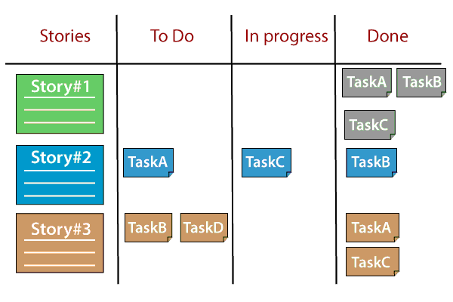

**Scrum board is divided into columns such as:**

* **Stories:** This column contains all the user stories available in the current sprint backlog.
* **TODO:** This state contains the subtasks of the stories on which the work has not started on.
* **In Progress:** This state contains all the tasks on which the work has started.
* **Done:** This state contains all the tasks at which all the work have been completed.

14) List all the reports generated by Kanban projects in Jira?

**The two types of reports are generated by Kanban projects:**

* **Control chart**

The control chart is a useful chart which helps in measuring the team's performance. The control chart displays the average cycle time of your team over a period of time. The control chart plots the following issues on the chart:

* Any issues which are outside the standard deviation known as outliers.
* It displays the average time taken to complete the tasks.
* It also displays the team's rolling average.

It displays the average cycle time of your product, version, or a sprint.

It helps you to identify whether the data from the current sprint determines the future performance of a product, i.e., the less variance in the cycle time means that median or mean can determine the future performance.

**How to create a Control flow chart**

**The following are the steps to create a control flow chart:**

* Go to the Jira official website.
* Click on the project on which you are working.
* Click on the Reports appearing at the left side of the panel.
* Select the Control chart.
* **Cumulative flow diagram**
  + Cumulative flow diagram is a kanban tool that allows the team to view the effort and project's effort.
  + Cumulative diagram consists of two axis, i.e., X-axis and Y-axis where X-axis (horizontal axis) represents the time taken to complete a task and Y-axis (vertical axis) represents the number of issues or tasks.
  + The size of the area represents the number of work items currently involved in each state for the selected time period.

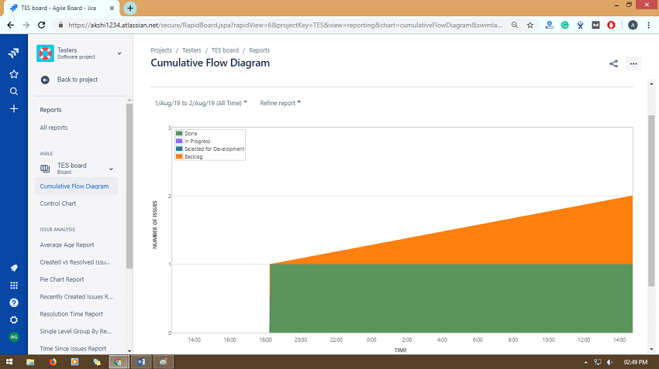

**Features of Cumulative flow diagram:**

* **Monitor how WIP builds over time**  
  If the line goes up, which means that WIP (Work In Progress) goes up means that the team is working on more tasks than handling them at a time. Increase in WIP results in increased cycle times, and this reduces team efficiency. So, it is important to keep the line straight.
* **Observe how much team delivers**  
  With the help of CFD diagram, we can keep track of all the tasks which have been delivered by the team. If the bottom line of the CFD diagram represents the **Done** state, then the slope of the line between any two points would represent the average throughput between these two points.
* **Spot bottlenecks instantly**  
  Cumulative diagram determines the exact amount of work in each state of your project. If one or more areas represent that WIP is expanding, then CFD spots this bottleneck instantly.
* **Measure your past performance**  
  The horizontal difference between the top line and bottom line at any point provides the process approximate average cycle time. The comparison between the exact cycle time and approximate cycle time provides you a good understanding of the process performance.
* **Monitor your process health**  
  Cumulative flow diagram is used to evaluate the efficiency of a process and also helps to identify the problems to achieve a stable and healthy process. The average arrival rate must be close to the average throughput to achieve a stable system, i.e., **Average Cycle Time= Average Throughput**.

15) List all the reports generated by scrum projects in Jira?

**The following are the reports generated by scrum projects in Jira are:**

* **Burndown chart**  
  Burndown chart displays the amount of work that has been completed in a sprint, and the total work is remaining.  
  **Burndown chart is useful as it provides the following observations:**
  + If the team finishes its work early, which means that the team is not committed with sufficient work during sprint planning.
  + If the team does not finish its work within a sprint means that they are committed with a lot of work.
  + If the burndown chart drops sharply which means that the work has not been estimated properly.

**How to create a Burndown chart**

**The following are the steps required to create a Burndown chart:**

* Go the Jira official website.
* Click on the project on which you are working.
* Click on the **Reports** appearing at the left side of the panel.
* Select the **Burndown chart**.
* **Burnup chart**

Burnup chart is the visual representation of a sprint's completed work compared with the total scope. It is used to identify problems such as deviation from the planned project path.

**How to create a Burnup chart**

**The following are the steps required to create a Burnup chart:**

* Go to the **Jira** official website.
* Click on the project on which you are working.
* Click on the **Reports** appearing at the left side of the panel.
* Select the **Burnup chart** from the Reports dropdown.

**The following are the important points related to the Burnup chart:**

* The vertical axis represents the amount of work, and it can be measured in different ways such as Story points, issues count, or estimates while the horizontal axis represents the time in days.
* The distance between the lines on a chart is the remaining amount of work. When all the issues have been completed, the lines will meet.

16) Define a component in Jira?

Components are the subdivisions of a project and used to group the issues within a project into smaller parts.

17) How to delete a component in Jira?

**Follow the below steps to delete a component in Jira:**

* Click on the **Components** appearing at the left side of the panel.

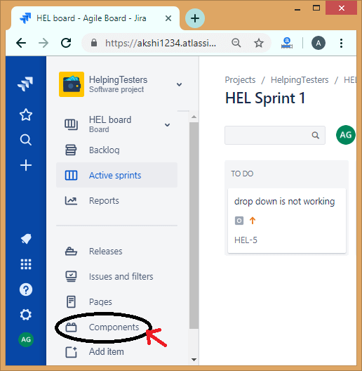

* Click on the '...' icon then the dropdown appears which shows two options, i.e., **Edit and Delete**.

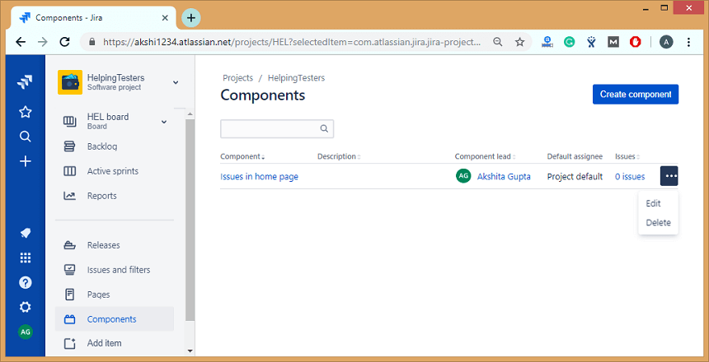

* Click on the **Delete** option to delete the component from the Jira project.

18) What is a validator in Jira?

Validators check whether the input provided by the user is valid before the transition is performed.

If the validation fails, then the issue does not proceed to the destination status of the transition.

**List of validators:**

* **Required Field validators**  
  Required field validator ensures that the field is mandatory or required. The required fields marked with the red asterisk (*) on every transition screen. In Jira, we can use the field configuration to make the fields compulsory or mandatory. With the help of Required field validators, it is possible to make the fields mandatory that makes the overall process more user-friendly.
* **Regular Expression Validator**  
  Regular Expression Validator checks whether the input given to a certain field matches the regular expression that you define. It is a quite powerful validator, and its use cases vary from the simple validation, the user should provide the exact value that matches the use cases.

**Parameters**

**Regular expression:** It is an expression that the input field should match.

**User define message:** This message appears when the validation fails.

* **Validator to compare to two fields with each other**  
  This validator is used to compare the two fields. To use this validator, both the fields must be of the same type.  
  **The following is the list of operators that this validator supports:**
  + **> ( greater than)**
  + **< ( less than)**
  + **>= (greater than or equal to)**
  + **<= (less than or equal to)**
  + **= (equal)**
  + **!= (Not equal)**
* **Date Compare Validator**  
  The **Date Compare Validator** is used to compare the date field with the fixed date. It can support the date field types such as Date fields (Date and date with time). We can use a fixed date in the format yyyy-mm-dd hh:mm or a pattern (days, months, weeks, years).
* **Field Compare Validator**  
  Field Compare Validator is a validator that compares the fields against the fixed values.  
  **It supports the following operators:**
  + = (equal to)
  + != (Not equal to)
  + > (greater than)
  + >= (greater than or equal to)
  + < (less than)
  + <= (less than or equal to)
  + IN
  + NOT IN
  + CONTAINS

It supports the comparison types such as String, Number, and Option ID. For example, we have a field named "Salary", and its field value should not be less than 30,000, it can be represented as:  
Salary>=30,000;

* **User in Project Role Validator**  
  This validator ensures that the currently logged in user should be in a certain specific role. For example, only a user with a role "Developer" can do this workflow transition.
* **User in Group Validator**  
  It validates that the current user should be in any of the specified groups.
* **User in Field Validator**  
  This validator ensures that the current logged in user is set on a certain field.  
  There are two options available in this validator:
  + You can set the status of a current user in a field.
  + He/she is not set in this field.
* **Parent Issue Type Validator**  
  This validator is used to prevent creating the subtasks from the parent issue. We can achieve this by adding a validator to the "Create" transition from the subtask. You can also provide a custom error message for this type of validator.
* **Parent Issue Status Validator**  
  This validator ensures that the parent issue should have some specific status. The status can be Reopened, In Progress, Backlog, etc.
* **Field Values Changed Validator**  
  Field Values Changed Validator ensures that the user can change the value in a field.
* **JQL Validator**  
  JQL (Jira Query Language) evaluates the current issue against the JQL query. In JQL Validator, the query is generated automatically related to the issue.  
  JQL Validator provides some additional fields:  
  **Validator message:** It is used to define the custom error message if the validation fails. If you do not want to provide the custom error message, then you can leave this field as empty.  
  **Run as user:** In this field, we can define a technical user with which the JQL expression will be evaluated. If you leave this field as empty, then the current user will be considered for this transition.

19) What is an issue collector?

An issue collector allows you to gather the feedback form of any website in the form of Jira issues. It can also collect the issues who do not have a Jira account.

20) What are the differences between Scrum board and Kanban board?

**The following are the differences between Scrum board and kanban board:**

|  |  |  |
| --- | --- | --- |
|  | **Scrum** | **Kanban** |
| **Planning** | It has fixed planning. It focussed on planning. It starts with the sprint planning and ends with the sprint review, retrospective. The daily meeting is held so that the team knows the next steps, priorities, and the learnings from the previous steps. | It has no fixed planning, and no daily meetings are conducted. In Kanban, changes can occur at any time, i.e., frequent changes occur. |
| **Timeline** | In scrum, we work on the sprint that has the fixed-time duration means that after some fixed-time, we are delivering something to the client. | Kanban does not have the concept of a sprint, so it has no fixed timeline for delivering the product to the client. |
| **Task estimates** | During sprint planning, it is decided that how many activities are to be pulled from the product backlog and add in a sprint backlog. For example, if the sprint is for two weeks, then the number of activities are selected in such a way that they can be completed within the sprint, i.e., in two weeks. | It does not estimate the task. |
| **Scrum Master** | In scrum methodology, we have one scrum master who handles the team and conducts the meeting on a daily basis. | In Kanban methodology, we do not have any scrum master. It's the responsibility of each individual to deliver a valuable product. |
| **Suitability** | This methodology is suitable for large-sized projects as large-sized projects can be divided into multiple sprints. | It is mainly suitable for small-sized projects. |
| **Constant changes** | In Scrum, constant changes can be adapted easily in shorter sprints. | If any major change occurs, then Kanban methodology gets failed. |
| **Cost** | In Scrum, the task is estimated, i.e., a fixed number of activities are taken in a sprint, so the total cost of the project is minimal. | In Kanban, the task is not estimated, so the total cost of the project is not accurate. |
| **Roles and responsibilities** | In Scrum, a specific role is assigned to the team members by the Scrum Master while the product owner tells the objectives of the product on which team members have to work. | No predefined role is assigned to the team members. It's the responsibility of all the team members to work in collaboration to deliver a valuable product. |
| **Measurement of Productivity** | The productivity is measured by using cycle time or the time taken to complete the whole project from start to the end. | Productivity is measured by using velocity through sprints. |
| **Release Methodology** | Small release after the end of each sprint. | It provides continuous delivery. |

javaTpoint end --jira